Music & Sound fx:

<https://www.youtube.com/audiolibrary/music>

<http://freemusicarchive.org/>

<http://opengameart.org/>

<http://www.freesound.org/>

library of websites to choose from

<https://copyrightfriendly.wikispaces.com/Copyright-friendly+music+and+sound>

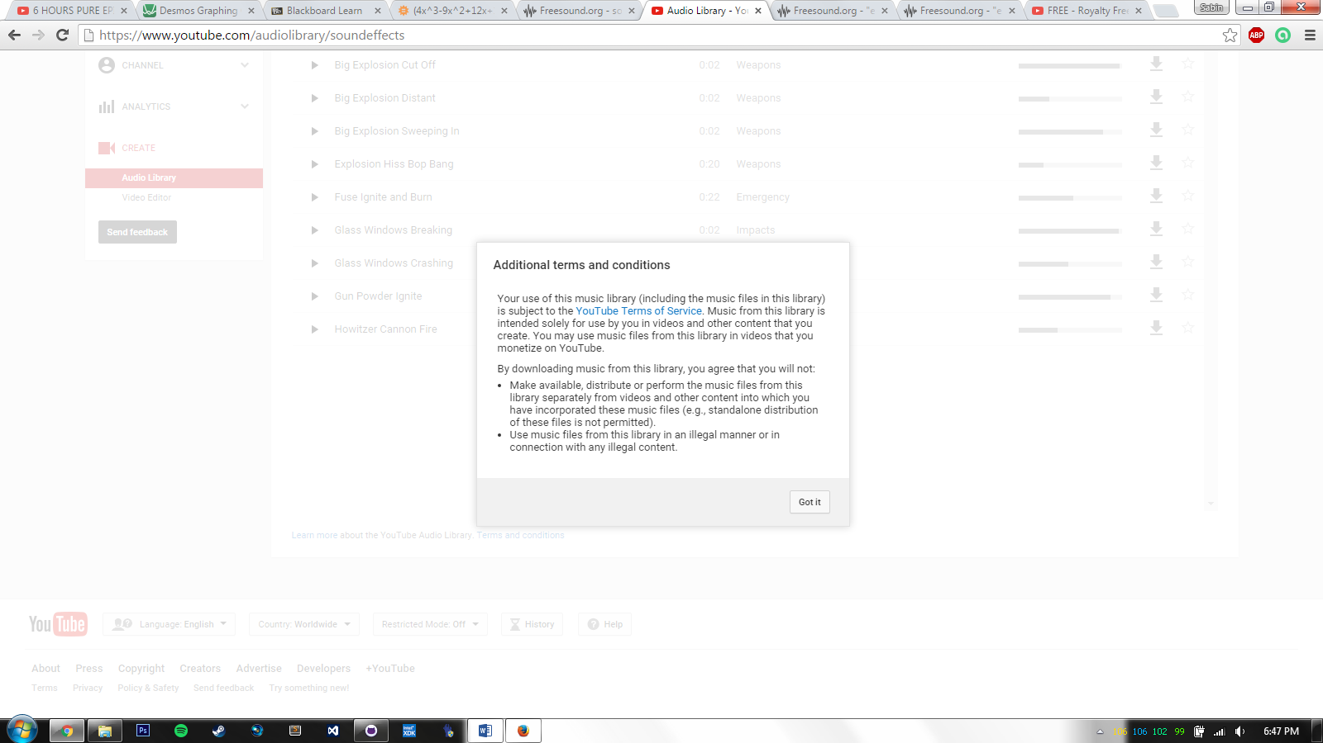

Sprite stuff:

Creator: <http://www.piskelapp.com/p/agxzfnBpc2tlbC1hcHByEwsSBlBpc2tlbBiAgIDwzt7kCgw/edit>

Tester: <http://www.leshylabs.com/apps/spriteSheetAnimator/#demo>

stitcher: <https://draeton.github.io/stitches/>

Cordova plugins:

<https://cordova.apache.org/plugins/>